**SIROWA TALLINN AS**

**IT DOCUMENTATION**

**Temperature an Humidity Monitoring in the Baltic Warehouse**

# Document Information

|  |  |
| --- | --- |
| **Document Title:** | Temperature and Humidity Monitoring in the Baltic Warehouse |
| **File Name:** | SENSOR V1.1b.docx |
| **Last Saved:** | 18.06.2021 |
| **Last Printed:** | 11.05.2021 |

Document Owner

|  |  |  |  |
| --- | --- | --- | --- |
| **Date of Creation** | **Owner** | **Email** | **Responsible Group** |
| 18.03.2021 | Annely Martoja | [annely.martoja@sirowa.com](mailto:annely.martoja@sirowa.com) | Baltic Warehouse |

Revision History

|  |  |  |  |
| --- | --- | --- | --- |
| **Version** | **Date** | **Updated By** | **Description of Changes** |
| 0.1 | 24.03.2021 | Karl Oskar Anderson | Remade documentation to match the new Comet System remote web based solution |
| 1.0 | 18.05.2021 | Aivar Lindam | Corrections and serverside information |
| ??? | ??? | ??? | ??? |
| 1.1b | 17.06.2021 | Karl Oskar Anderson | Changed Sensor Logserver and db section to match new solution. There is a v1.1 by Aivar so this document should be merged with that. |

Document Approvers

|  |  |  |  |
| --- | --- | --- | --- |
| **Date** | **Name** | **Title** | **Signature** |
|  | Annely Martoja | Head of Baltic Warehouse |  |

Responsibilities

|  |  |  |  |
| --- | --- | --- | --- |
| **Responsibility title** | **Name** | **Title** | **Responsibilities** |
| System Owner, Primary User | Annely Martoja | Head of Baltic Warehouse | System validation, monitoring, documentation owner |
| Workplace and network admin | Softsystems IT | IT specialist | Sensors monitoring, network and hardware support |
| Sensor Logserver administrator | Aivar Lindam, Alan Vezbickis (Sergej Bial) | IT specialist | System validation, Sensor Logserver administration |

# **Table of Contents**

Document Information 2

Table of Contents 4

Introduction 6

1. System overview 7

2. Sensors 8

2.1. Sensor Naming 9

2.2. Sensor Placement 9

3. ACCESSING SENSORS AND CONFIGURATION 12

3.1. Sensor configuration 13

3.1.1. General Settings 13

3.1.2. Network Settings 13

3.1.3. Alarm limits Settings 13

3.1.4. Measuring Settings 13

3.1.5. SOAP Settings 13

3.1.6. Email Settings 14

3.1.6. SNMP Settings 14

3.1.7. Time Settings 14

3.1.8. WWW and Security settings 14

3.2. Sensor Monitoring, Alerts, Faulty situations 15

3.2.1. Sensor Monitoring 15

3.2.2. Sensor Alerts 15

3.2.3. Faulty situations (only stationary sensors) 15

3.3. Sensors and Temperature/Humidity regular Control 16

3.3.1. Sensors and Temperature/Humidity control in warehouses 16

3.3.2. Sensors and Temperature/Humidity control in transportation vehicles 16

3.3.3. Sensors and Temperature/Humidity control in transportation vehicles 16

6. SENSOR logserver – http://sensor.sirowa.EE 17

6.1. SOAP request data saving 17

6.2. User interface 18

6.2.1. Overview 18

6.2.2. Graph 21

6.3. Sensor Logserver technical description 22

6.4. Sensor Logserver Database structure 23

6.3. Sensor Logserver backup and monitoring 23

6.4. Administrating Sensor Logserver 23

Appendix 1 24

Comet System and Calibration Certificates 24

Appendix 2 24

Warehouse Temperature and Humidity control report template (in estonian) 24

Appendix 3 24

User manuals 24

Appendix 4 25

Local distributor contact 25

# Introduction

This Document describes Temperature and Humidity Monitoring System in the Sirowa Baltic Warehouse. Address: Sirowa Tallinn AS, Salve 2C and 2D, Tallinn 11612, Estonia.

Document consists general information, technical description (hardware and software) and maintaining procedures of the Temperature and Humidity Monitoring System.

# 1. System overview

Temperature and Humidity Monitoring System (hereinafter THMS) provides automated temperature and humidity recording and monitoring in warehouses where pharmaceutical products are handled and stored.

Sensors are sending temperature values to the Sensor LogServer http://sensor.sirowa.ee . Visual graph shows temperature fluctuation in choosed period. All values are saved in central database.

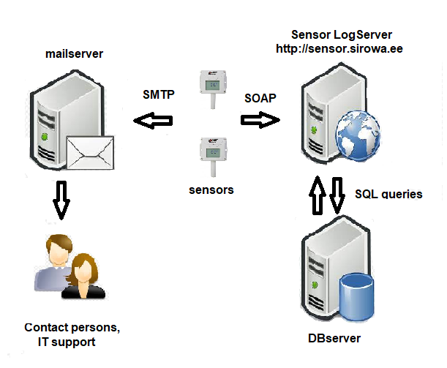

* Sensors send information to the Sensor Logserver using XML based SOAP (Simple Object Access Protocol)
* All values are saved to the MariaDB database and read from database for creating graphs using SQL queries
* All alerts from sensors are sent using SMTP protocol over mailserver to the persons who are responsible for warehouses and IT support

# 2. Sensors

Sirowa Tallinn AS is using Comet System sensors which calibration certificate results from the ISO/IEC 17025 standards. Certificates from Comet System are included in APPENDIX 1

Comet System sensors allow:

* Measuring and processing input quantities
* Finding and storing minimal and maximal values of each measured quantity (since their last reset)
* Acquiring autonomous time record of measutred values
* Creating alarm states and perform actions (audio and/or optical signalization, alarm output signal, report messages)
* On-line monitoring of the measured values. Accessing these values via the web.
* Collecting and processing data in the central database
* Powering of stationary sensors by external power supply,
* Powering of portable sensor by NiMH accumulators or alcaline batteries or by external power supply

The following models are used:

* Comet System Web Sensor T3510, 5 pcs, stationary devices installed in the Pharma warehouses
* Comet System Multilogger M1140, portable , for testing and measurements

## 2.1. Sensor Naming

Sensors are named and labeled to logical standard. In EE, the devices are named as follows: (EE for country code, then device nr - then the location of controller. Sensor location height can be specified by adding ‘-U’ or ‘-D’ meaning UP or DOWN.

|  |  |  |
| --- | --- | --- |
| **Name** | **model** | **location** |
| **EE01-PHARMA** | T3510 | Pharma warehouse, 3rd floor |
| **EE02-ZLADU-U** | T3510 | Pharma warehouse, 1st floor, in the middle, up high |
| **EE03-ZLADU-D** | T3510 | Pharma warehouse, 1st floor, in the middle, down low |
| **EE04-LABELING** | T3510 | Pharma warehouse, 1st floor, labeling area |
| **EE05-DLADU** | T3510 | Pulsaar warehouse |
| **EE07-PORTABLE** | M1140 | IT department |

## 2.2. Sensor Placement

Sensors are marked on maps below as dark red circles.

* **EE02-ZLADU-U**
* **EE03-ZLADU-D**
* **EE04-LABELING**

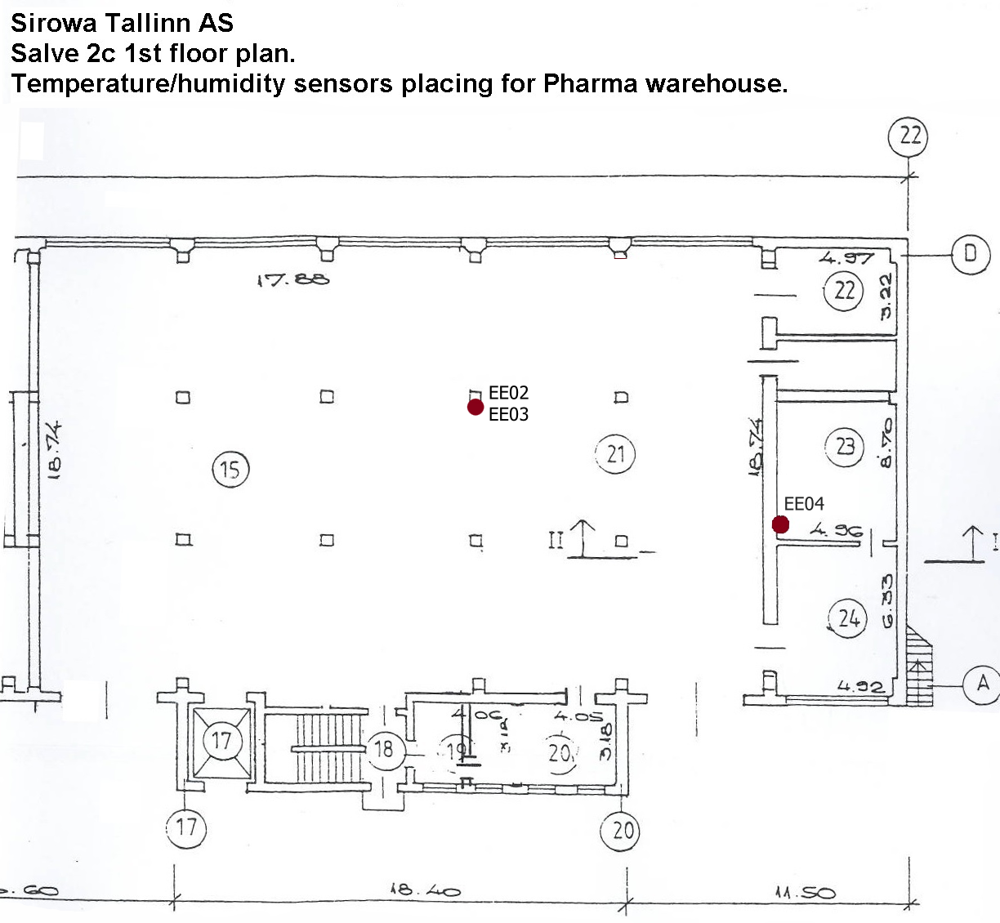

Devices EE02 and EE03 are located at different heights.

* **EE01-PHARMA**

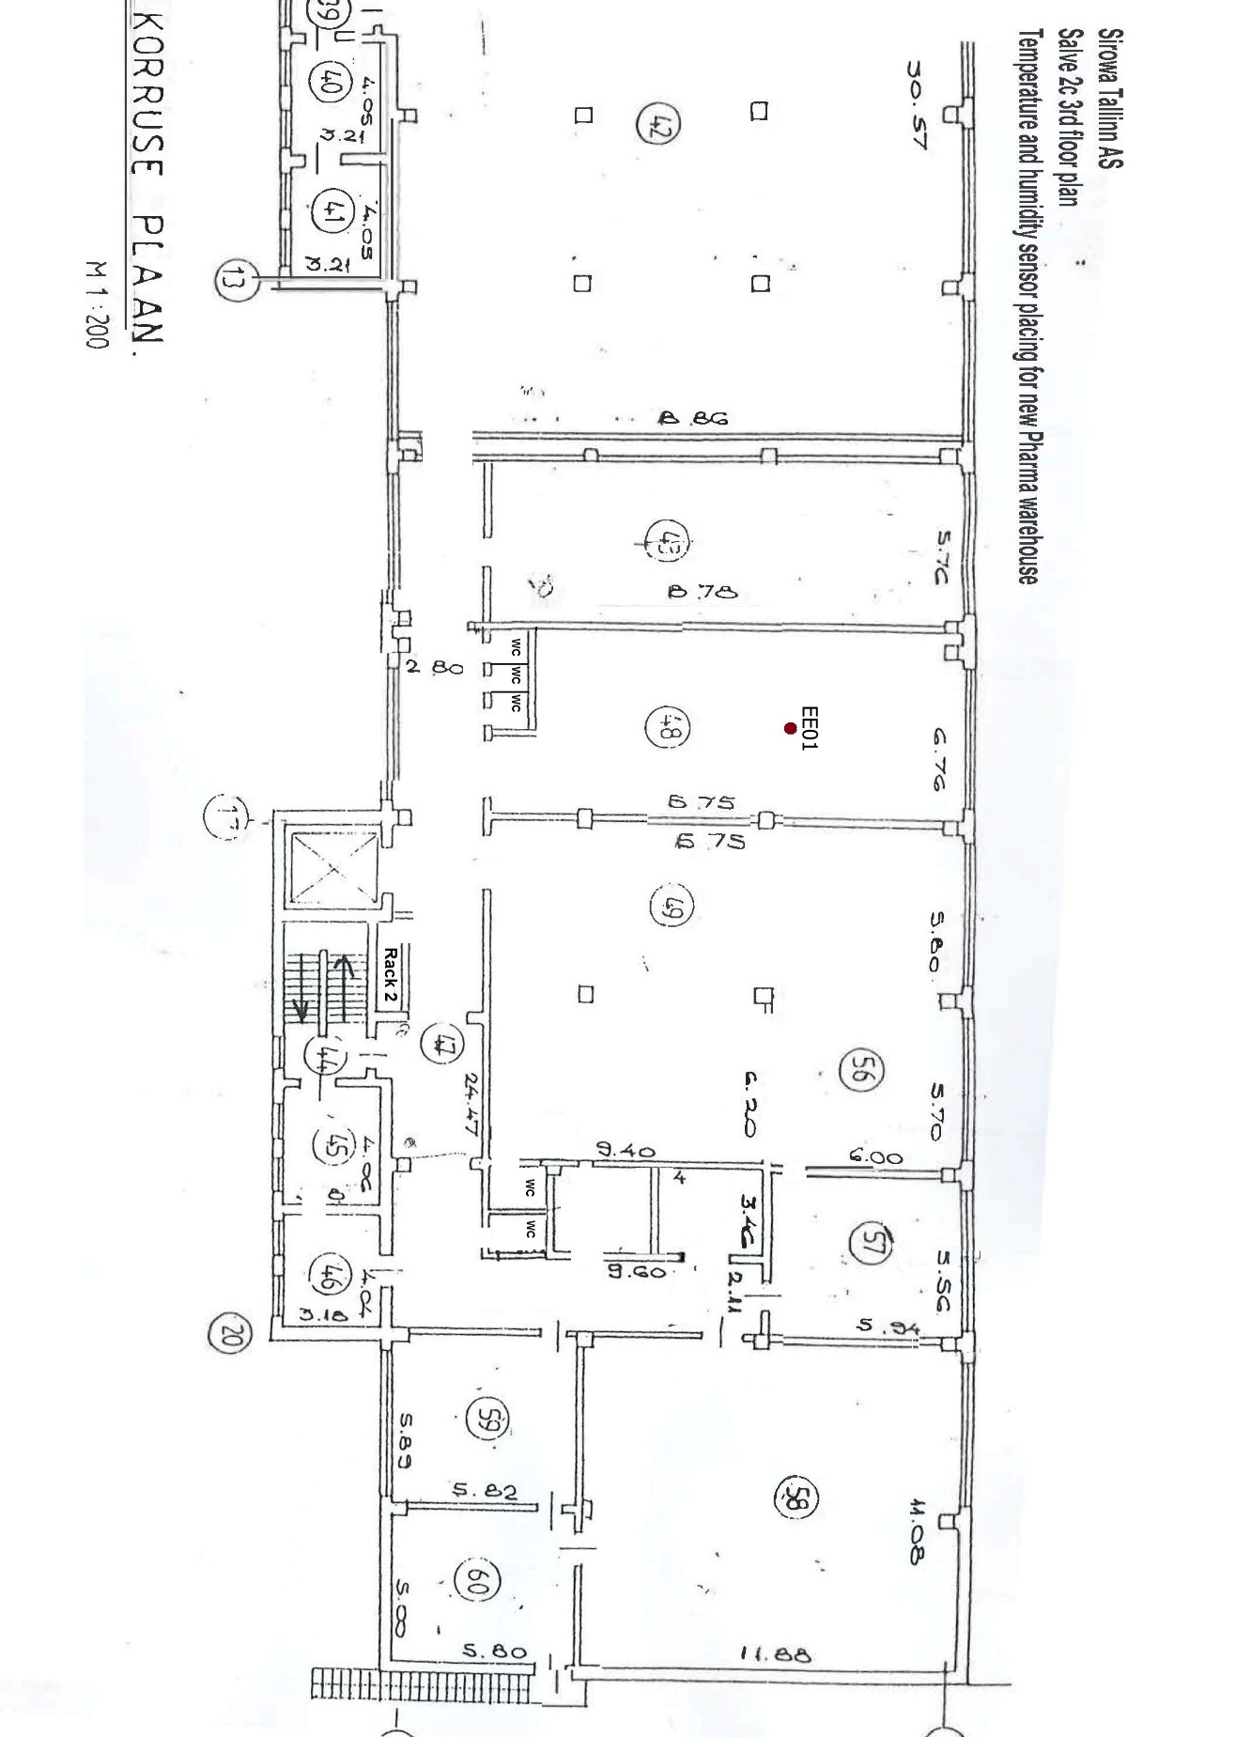

* **EE05-DLADU**

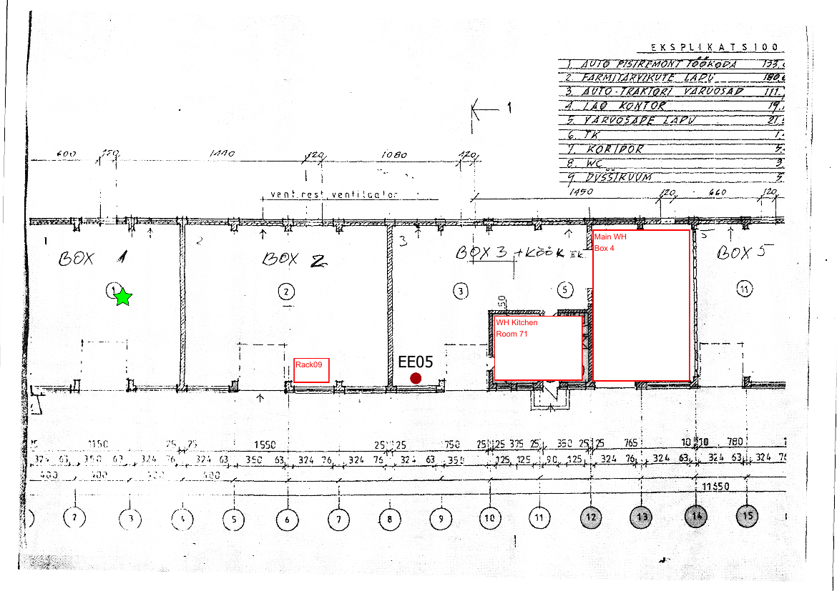

# 3. ACCESSING SENSORS AND CONFIGURATION

There are two ways to acces sensors:

1. By accessing Sensor Logserver webpage: <https://sensor.sirowa.com> ( p 6. ).

2. By using direct links to the sensor embedded web:

* + Link to [EE01-Pharma](http://10.37.2.15/) ( or <http://10.37.2.15> )
  + Link to [EE02-ZLADU-U](http://10.37.2.16/) ( or <http://10.37.2.16> )
  + Link to [EE03-ZLADU-D](http://10.37.2.17/) ( or <http://10.37.2.17> )
  + Link to [EE04-LABELING](http://10.37.2.18/) ( or <http://10.37.2.18> )
  + Link to [EE05-DLADU](http://10.37.2.19/) ( or <http://10.37.2.19> )
  + Link to [EE07-PORTABLE](http://10.37.2.14/) ( or <http://10.37.2.14> ) – mainly turned off

The following information/links are present on sensors embedded web page:

* Actual temperature, relative humidity and dew point – access to the sensors internal graphs
* Export values from sensor memory/history
* Memory clearing page
* Mobile view (not used in Sirowa)
* Settings – sensor internal configuration, only for configuration changes – password protected
* About – Links to general information

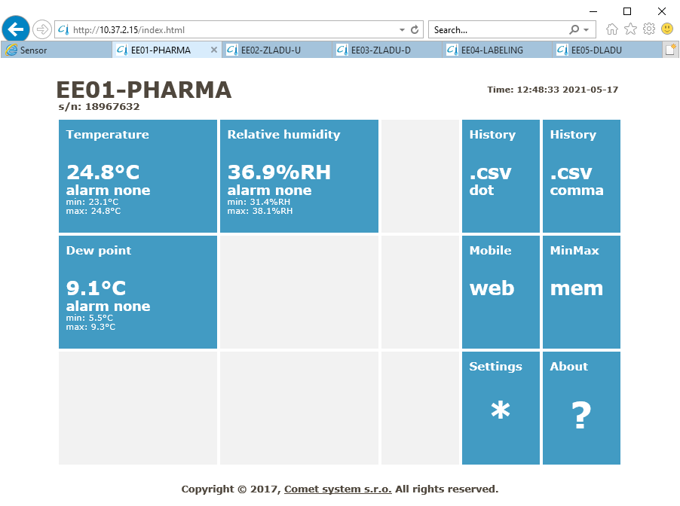

## 3.1. Sensor configuration

Choose **Settings on** sensors embedded web page and login using administrative username and password.

The following settins are used:

### 3.1.1. General Settings

- Device name: EE01-PHARMA example (described in p 2.1)

- History storage interval: 1 Hour interval of saving values in sensors memory

(1000 values supported for both channels)

### 3.1.2. Network Settings

- Obtain an IP address automatically YES

- Periodic restart interval OFF

### 3.1.3. Alarm limits Settings

- **Temperature limits**

|  |  |  |  |
| --- | --- | --- | --- |
| High limit [°C] | Low limit [°C] | Hysteresis [°C] | Time delay [sec] |
|  |  |  |  |

- **Temperature limits**

|  |  |  |  |
| --- | --- | --- | --- |
| High limit [%RH] | Low limit [%RH] | Hysteresis [%RH] | Time delay [sec] |
|  |  |  |  |

- **Dew point limits**

|  |  |  |  |
| --- | --- | --- | --- |
| High limit [°C] | Low limit [°C] | Hysteresis [°C] | Time delay [sec] |
|  |  |  |  |

### 3.1.4. Measuring Settings

- LCD enabled YES

- Show temperature YES

- Show Relative humidity YES

- Show Computed value NO

- Temperature unit C*

- Computed Value Dew point

### 3.1.5. SOAP Settings

The following is description how sensor connects to the Sensor Logserver:

- SOAP protocol enabled YES

- SOAP server address http://sensor.sirowa.com/temp.php TODO!

- SOAP server port 80

- Sending interval 15 Min

- Send SOAP message when alarm occurs: YES

- Computed Value Dew point

### 3.1.6. Email Settings

**SMTP server configuration** (emails are sent out using this server):

- SMTP server address 10.255.20.233

- SMTP server port 25

**Email configuration** (email alert sender and receiver addresses):

- Email sender address sensor.”sensor name”@sirowa.ee (described in p 2.1)

Example: sensor.EE01-PHARMA@sirowa.ee

- Recipients (same in all sensors): annely.martoja@sirowa.com

kristjan.sokk@sirowa.com

aivar.lindam@sirowa.com

**Example of (test)email:**

From: sensor.EE02-ZLADU-U@sirowa.ee

To: aivar.lindam@sirowa.com

Current values:

Ch1-Temperature: 23.2°C

Ch2-Relative humidity: 46.0%RH

Ch3-Dew point: 11.0°C

Settings:

Ch1: High limit: 25.0°C, Low limit: 15.0°C, Hysteresis: 0.0°C, Time delay: 30sec

Ch2: High limit: 60.0%RH, Low limit: 10.0%RH, Hysteresis: 0.0%RH, Time delay: 30sec

Ch3: High limit: 100.0°C, Low limit: -30.0°C, Hysteresis: 0.0°C, Time delay: 30sec

### 3.1.6. SNMP Settings

SNMP (Simple Network Management Protocol) allows to send alert messages to the central monitoring server – Zabbix.

### 3.1.7. Time Settings

The correct device time is needed for proper timing of temperature and humidity values

Time synchronization enabled YES

SNTP server IP address 216.239.35.0

GMT offset [min] 120

NTP synchronization every hour YES

### 3.1.8. WWW and Security settings

Access to the sensors settings need admistrative username and password (IT support).

Sensors write values into their own memory (1000 values per channel supported).

**Embedded web server settings:**

Web server enabled YES

WWW port 80

WEB refresh interval 30 sec

## 3.2. Sensor Monitoring, Alerts, Faulty situations

### 3.2.1. Sensor Monitoring

All sensors support SNMP protocol allowing to send SNMP traps (UDP port 161) to the Sirowa central monitoring server.

Additionally this is possible to create sensor status monitoring on Sensors Logserver locally in Estonia.

*Development planned on 2021*

### 3.2.2. Sensor Alerts

The following are contact persons receiving sensor alerts:

* Annely Martoja, [annely.martoja@sirowa.com](mailto:annely.martoja@sirowa.com) , Head of Baltic Warehouse
* Kristjan Sokk, [kristjan.sokk@sirowa.com](mailto:kristjan.sokk@sirowa.com) , Softsystems IT administrator
* Aivar Lindam, [aivar.lindam@sirowa.com](mailto:aivar.lindam@sirowa.com), Sirowa IT specialist

Temperature and humidity is registered after every 15 min (900sec) period. Deviations what exceed set temperature limits (25°C max or 15°C min) by 0,1°C or humidity limit by 0,1% (60% RH max or 10% min) by will be sent as email alerts to the contact persons.

*Planned on 2021 - Hysterezis tests.*

### 3.2.3. Faulty situations (only stationary sensors)

Network connection lost with Sensor LogServer:

* Sensors monitor Temperature and Humidity, alerts will be sent out

Sensors lost network connection:

* Sensors monitor Temperature and Humidity, saving values locally (41 days period – 1000 values – 1 per hour). No alerts.

Sensors lost external power supply

* Sensors do not monitor and do not send out alerts. Internal log will be cleared.

Sensors hardware problems (showing on LCD display)

* This is possible to reset sensors but contacting official support provided by distributor is needed

## 3.3. Sensors and Temperature/Humidity regular Control

### 3.3.1. **Sensors and Temperature/Humidity control in warehouses**

Target of regular controls is to check sensors and warehouse temperature/humidity values in different climate conditions (warm, cold, humid, dry): April, July, October and January

Measurements are peformed using portable sensor placing it in critical areas:

- near doors/gates

- at height ~20 cm and ~180 cm

- near stationary sensors for comparison values between stationary and portable sensors

### 3.3.2. Sensors and Temperature/Humidity control in transportation vehicles

Target of regular controls is to check transportation vehicles temperature/humidity values in different climate conditions (warm, cold, humid, dry): April, July, October and January

Measurements are peformed using portable sensor placing near product packages:

- at the beginning of transportation

- at the end of transportation

- short distance within the city ~ 30 min

- long distance between the cities ~2 hours

### 3.3.3. Sensors and Temperature/Humidity control in transportation vehicles

Measurement report must be filled using template – APPENDIX 2 – and signed by:

* Head of Baltic Warehouse, Annely Martoja
* Appointed tester (driver, It specialist etc)

# 6. SENSOR logserver – http://sensor.sirowa.EE

Link to the Sensor Logserver: <http://sensor.sirowa.ee>

Temperature Log Server makes possible central alerting and visualisation of SIROWA Warehouse control sensor data.

## 6.1. SOAP request data saving

Sensor Logserver consolidates all temperature values sent by Comet System sensors into the server database. Data sending configuration is described in p 3.1.5. Sent XML data handling:

|  |  |  |
| --- | --- | --- |
| XML element | Description | Database saving note |
| <passkey> | Device serial number (eight digit number) | Discarded! Only used to find correct sensor then discarded. |
| <device> | Device model identification number. Number-device mapping:   |  |  | | --- | --- | | **Number** | **Device** | | 4107 | T3511 | | 4106 | T4511 | | 4129 | T7511 | | 4124 | T2514 | | 4144 | T0510 | | 4145 | T3510 | | 4146 | T7510 | | 4173 | T0610 | | 4174 | T4611 | | 4175 | T3610 | | 4176 | T3611 | | 4177 | T7610D | | Discarded! Device model is already saved in database table named sensor. Only value is 4145 is received. |
| <temp> | Temperature (decimal number, decimal point is dot). Error value 9999 or -9999 | Saved! |
| <relHum> | Relative humidity (decimal number, decimal point is dot). Error value 9999 or -9999. | Saved! |
| <compQuant> | Computed value/quantity. Error value 9999 or -9999. | Discarded! Computed value is dew point %. Can be calculated from fields temp and relHum when required. |
| <pressure> | Atmospheric pressure. Error value -9999. | Discarded! Device in use (T3510) does not measure pressure. Sent value is always -9999. |
| <alarms> | State of alarm on temperature, relative humidity, computed quantity and pressure channel. Alarm values: no–no alarm or value is not supported, hi–high alarm, lo–low alarm.  Example: “no,hi,no,no” | Discarded! Holds no actual information. Sensor min/max alarm limits are saved into table named sensor. |
| <compType> | Computed quantity type: Absolute humidity, Specific humidity, Mixing proportion, Specific enthalpy, Dew point or n/a. | Discarded! Computed quantity is discarded. |
| <TempU> | Temperature and Dew point unit. Values: C, F, n/a | Discarded! Expect values to be in C. |
| <pressureU> | Atmospheric pressure unit. Values: hPa, PSI, inHg, mBar, oz/in^2, mmHg, inH2O and kPa. | Discarded! Pressure is discarded! |
| <timer> | SOAP sending interval in seconds. | Discarded! Holds no actual value. |

When server receives the SOAP request current time is saved as field dateRecorded in format YYYYMMDDHHmm.

## 6.2. User interface

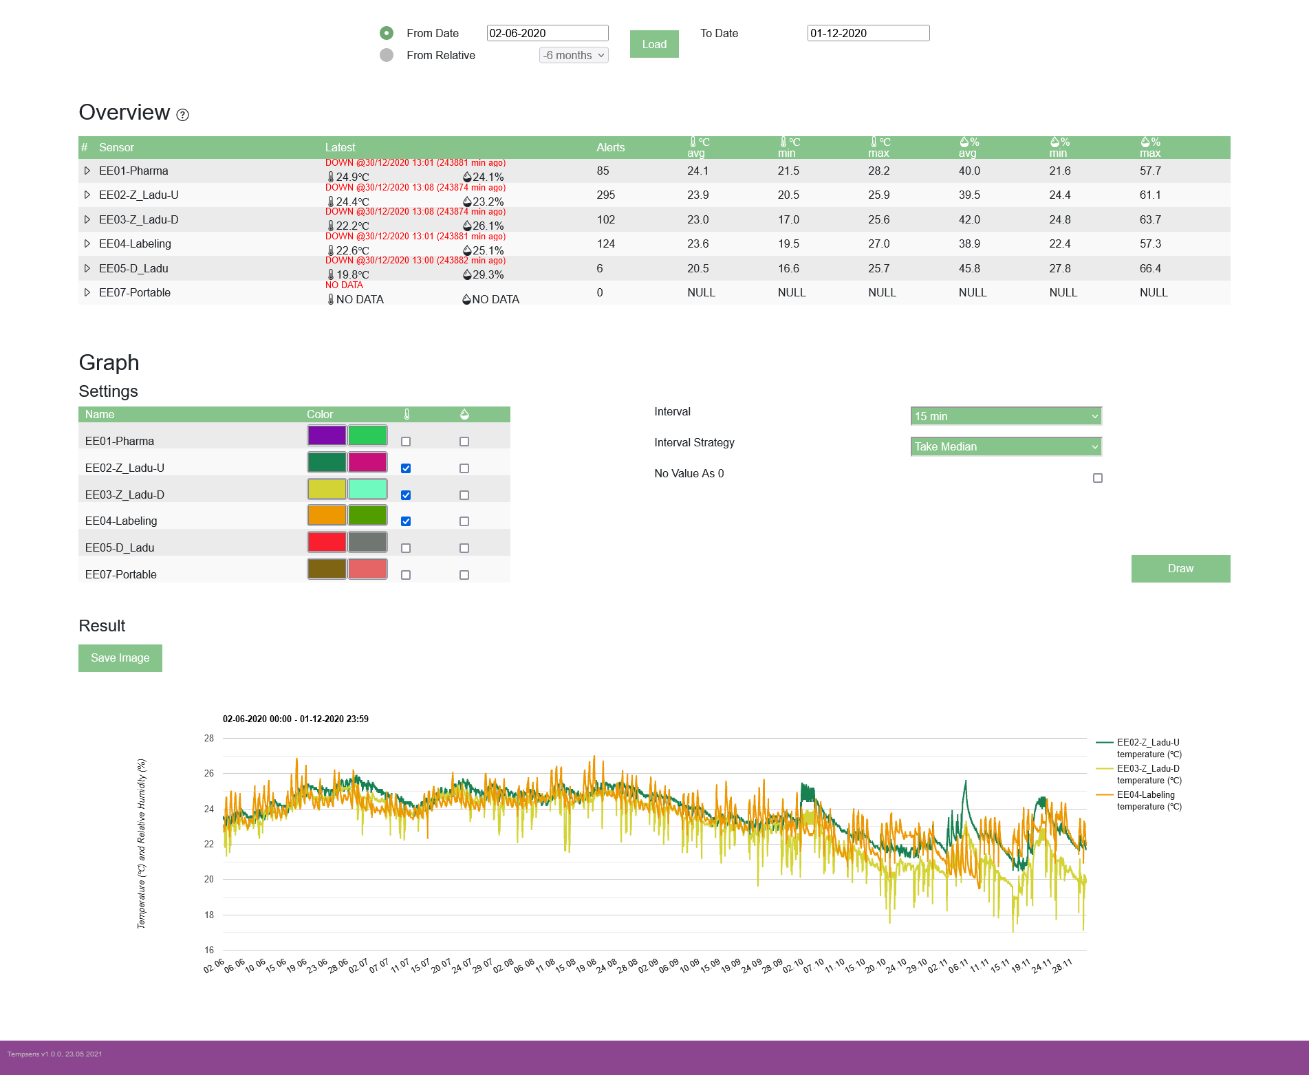

Load sensor data by selecting desired From and To date and click Load.

### 6.2.1. Overview

All existing sensors are shown in Overview table. First column shows sensor name. Column Latest shows last saved reading date, temperature and relative humidity, is independent of selected period. Column Alerts shows number of grouped sensor readings that are outside allowed temperature and humidity min/max range in selected period. Last 6 column show average temperature, minimum temperature, maximum temperature, average relative humidity, minimum relative humidity and maximum relative humidity between selected period.

Clicking on a sensor row will open up extra sensor information and functionality.

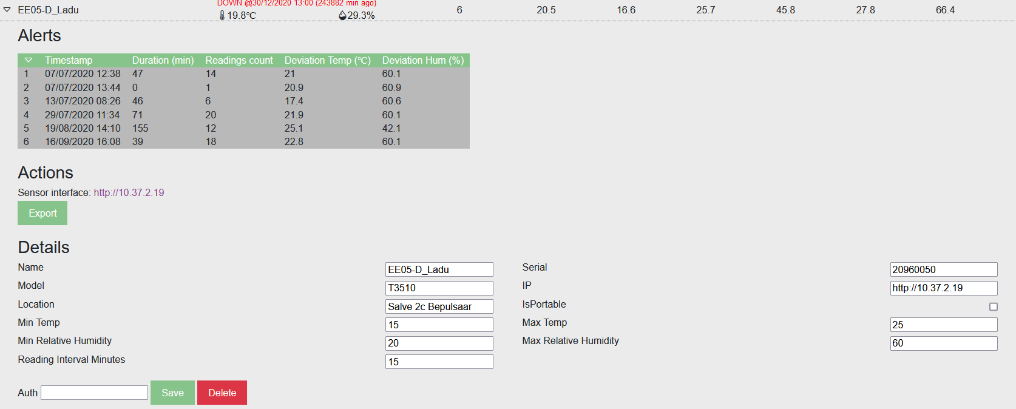

**Alerts**

Alerts will show show exact alert starting time and approximate duration. Reading count is correlated to alert duration, it shows the amount of sensor readings that were recorded to be outside allowed min/max temperature and relative humidity range. Deviation shows the highest/lowest reading for temperture and relative humidity during the alert.

**Actions**

**Actions – sensor embedded server**

Sensor interface shows a link to the sensor embeded web server. The main purpose of sensor embeded server is to view and change sensor configuration. It also has functionality to export data and view graphed data, but sensor logserver handles both of these functionalities better.

**Actions – export**

Clicking on Export button exports sensor reading data in selected period in semicolon delimited CSV format.

**Actions – uploading data**

Portable sensors allow to upload sensor readings by uploading CSV files. This requires a web authentication password and access to a portative sensor. CSV files can be obtained through COMET Vision software by connecting a portable sensor to a computer with miniUSB to USB cable and downloading the data from the device.

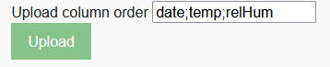

Upload column order defines uploaded CSV file columns and their expected values. Must have column values are: date, temp, relHum. Semicolon acts as column seperator.

Example 1. „date;temp;relHum“ will look for date value in the first column, second and third column will look for temp and relHum data respectively.

Example 2. „date;;;temp;relHum“ will look for date value in the first column, second and third columns will be skipped, fourth and fifth column will look for temp and relHum data respectively.

Clicking Upload opens a file selecion popup to choose the sensor data CSV file. The file will be parsed clientside by JavaScript according to Upload column orded value. If everything works well, the parsed data will show up as a popup.

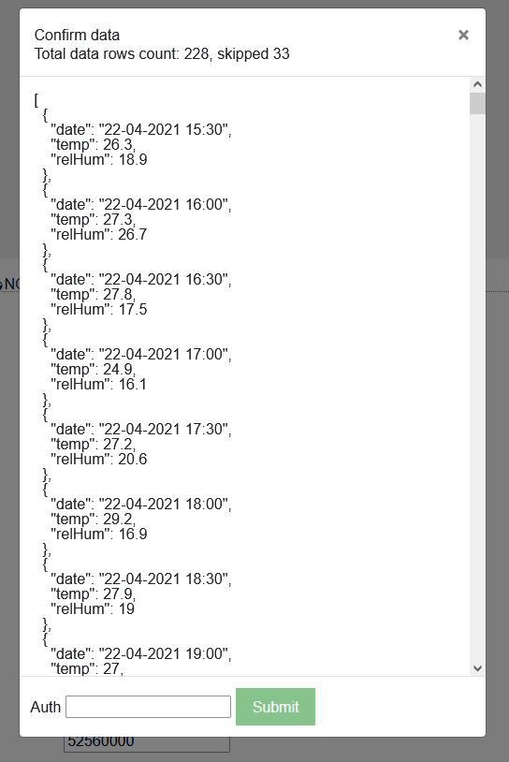

In this example the uploaded CSV file contained 1 header row and 228 data rows. 33 rows were skipped. Rows with empty fields or fields starting with Error will be skipped. Empty fields are commonly caused by accessing the portable sensor configuration settings, this cause the sensor to save the current date with empty measurement fields. Errors can be caused by various reasons, but most likely a sensor probe communication error.

Entering the authorization password and clicking submit will save the data or throw a error. Attempting to save already existing data partially or fully will throw a error – uploaded date values are being checked with existing dates.

**Details**

Details shows the sensor configuration. This configuration has 4 purposes. It is used in Sensor Logserver calculations, it shows non-technical sensor configuration to users, it reflects values stored in the database, it allows to perform CRUD (create, read, update, delete) operations on database values without accessing the database directly.

The settings here only mimic the sensor configuration – any changes here will not affect the sensor own configuration. All the info here is accessable by sensor embeded web page, but that is password locked and contains technical configurations that are more suited for authorized IT personnel.

Having an authorization password allows to perform CRUD operations on sensor values.

Example: Change sensor naming scheme. Write new value under sensor Name, input auth password, click save, server will save the new values to database and the site will reload with the new values.

### 6.2.2. Graph

Allows to visualize sensor readings in a linechart graph.



**Settings**

Settings allows to configure the values to be drawn.

In the table in the left user can specify chart line colors and whether to draw sensor temperature, humidity or both. Multiple sensors can be drawn at the same time.

On the right user can manipulate the drawn graph. Interval sets graph point interval. Possible values are 15 min, 30 min, 2 hours, 6 hours, 1 day.

Interval strategy changes how the data between 2 interval points is handled. Possible values are: Take median, Take average, Take deviation. Take median takes the closest date point value. Take average takes gets the average temperature or relative humidity between 2 interval points. Take deviation takes hightest/lowest temperature or relative humidity value between 2 interval points. Interval strategy has more impact on larger intervals.

No value as 0 checkbox allows to display no value between 2 interval points as value 0. This is useful to detect problems with missing sensor readings. If this option is not selected, the graph line will be cut from the missing value point (non-continues line), but this is hard to detect. This option has more impact on small intervals.

Example: Same graph as above, but No value as 0 selected.

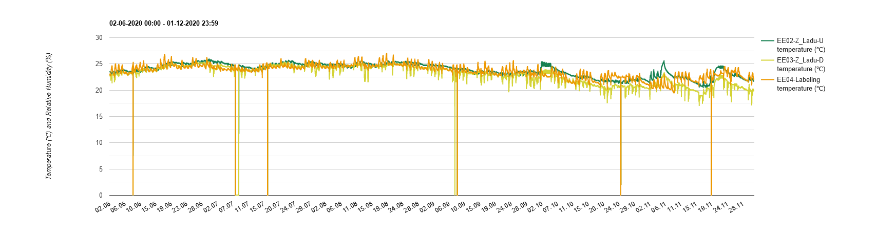

Click on Draw button to draw the graph.

**Result**

The graph drawing might take some time, depending on the amount of values to process. The processing is done by clientside (users computer) by JavaScript – faster computer works better.

Save image button allows to export the graph as a image. Functionaly this is the same as taking a screenshot, but more conveniant: no need for screenshotting software, image already properly cropped and named.

## 6.3. Sensor Logserver technical description

Network address: 10.37.2.20

Operating system: Centos7

Sensor Website is based on PHP/MySQL, NGINX webserver.

Solution is built using Docker containers and Docker Composer as orchestrator. 4 containers are used:

* git – Centos7 + git + compose. Used only for git updates
* cron – Centos7 + crontab + MySQL. Used for regular jobs (internal backup etc)
* db – Centos7 + MariaDB. Application database name is “tempsens”
* nginx – centos7 + nginx + php. Web application server, running nginx, php, Sensor web application scripts

## 6.4. Sensor Logserver Database structure

## 

CREATE TABLE Sensor

(

Id VARCHAR(64) NOT NULL PRIMARY KEY,

Name VARCHAR(64) NOT NULL,

Serial VARCHAR(64) NOT NULL,

Model VARCHAR(64) NOT NULL,

Ip VARCHAR(64) NOT NULL,

Location VARCHAR(64) NOT NULL,

IsPortable INTEGER NOT NULL,

MinTemp DECIMAL(18,1) NOT NULL,

MaxTemp DECIMAL(18,1) NOT NULL,

MinRelHum DECIMAL(18,1) NOT NULL,

MaxRelHum DECIMAL(18,1) NOT NULL,

ReadingIntervalMinutes INTEGER NOT NULL

);

CREATE TABLE SensorReading

(

Id VARCHAR(64) NOT NULL PRIMARY KEY,

SensorId VARCHAR(64) NOT NULL,

Temp DECIMAL(18,1) NOT NULL,

RelHum DECIMAL(18,1) NOT NULL,

DateRecorded VARCHAR(64) NOT NULL,

DateAdded VARCHAR(64),

CONSTRAINT SensorReadingFKSensor FOREIGN KEY (SensorId) REFERENCES Sensor.Id

);

CREATE INDEX SensorReadingidxDateRecorded ON SensorReading(DateRecorded); TODO! Does this index have any effect? Needs testing.

Into SensorReading table, sensors feed active monitoring data (approching http:\\hostname\SoapMethods.php using SOAP call). Server IP or hostname and SOAP endpoint is configured using sensor admin page as described in main document.

## 6.3. Sensor Logserver backup and monitoring

*Planned on 2021. To be configured and described.*

## 6.4. Administrating Sensor Logserver

*Planned 2021*

*To be agreed and described.*

*Ssh keys*

*Authorized IT administrators*

# Appendix 1

## Comet System and Calibration Certificates

<https://www.cometsystem.com/userfiles/dokumenty_menu/13/ae-snc-txxxx.pdf>

<https://www.cometsystem.com/support/calibration-1>

Calibration sertificate document name standard: Sensor name – serial number

     

# Appendix 2

## Warehouse Temperature and Humidity control report template (in estonian)



# Appendix 3

## User manuals

 

# Appendix 4

## Local distributor contact

Evikontroll Systems OÜ

Reg: 12507017

VAT: EE101650634

Tartu Science Park

Teaduspargi 7/9, Tartu

20411 Estonia

Tel: +372 7336310

Email: [info@evikon.ee](mailto:info@evikon.ee)

Support Email: [support@evikon.ee](mailto:support@evikon.ee)